MAGENTIC SENSOR STRIP INSTALLATION GUIDE

Congrats on your purchase of your new Klutch Curling Products! We hope you and your club members enjoy them for years to come.

This guide is meant to help your ice technician(s) correctly install the equipment required to enable and use your curling sheet with the Klutch Curling App. Our commitment to safety, high quality ice making, and maintenance procedures remains paramount throughout our Klutch installation guide. We understand and appreciate the knowledge and experience that is essential for all professional ice technicians within their roles and responsibilities. Please use caution while ensuring that industry accepted methods & techniques are utilize during the installation process.

PLEASE BE CAUTIOUS HANDLED MAGNETS SAFELY, PARTICULARILY NEAR PERSONAL MEDICAL DEVICES

Please read and understand all safety precautions associated with the safe operation of your tools and equipment before use. Please be sure of ice depth before attempting to cut into ice by mechanical means. Concrete floors and/or brine pipes can be seriously / permanently damaged by rotating blades.

Suggested tools that may be required for your particular installation;

- Electric router with adjustable depth gauge and 1.125 in. (2.856cm) spade/mortising bit
- Circular saw with widest blade.
- 8ft. (2.44m) Straight edge router/saw guide
- 1.125 in. (2.856 cm) hand paint scraper
- wet/dry vacuum
- measuring tape and Chalk line (blue)
- Spray bottle with water
- Water container to flood trench

1. Getting your ice ready - Installing the Magnetic Sensor Strips

Inside your installation kit, you will find 1-inch (2.54cm) x 60 ft. (18.29m) continuous roll of black or white magnetic sensor strip.

There are two methods of installation of sensor strips; as part of your initial ice installation (preferred) or installing after your ice is already finished. While many of the steps and considerations are the same, there are some considerations that may vary.

PRO TIP: Unroll your magnetic sensor strips in the cold/ice shed the day before to flatten them out and simplify your install.

METHOD 1: Installation during Ice Making

While the installation process is relatively straight forward, the accuracy of the Klutch Curling App relies on the critical placement of the Magnetic Sensor Strips. Failure to perform all the steps described could impact the overall performance of the products. Please pay careful attention to all the steps below and if you have any questions please consult our website for further details or contact us for support.

We have found that each ice technician’s process and installation method is unique and dependent on both the club and environment. To support this, we have tried to be as flexible as possible in our approach to installation. Listed below are a number of key considerations:

  - Sensor Strip Depth. While the sensor strips can be installed at any depth in the ice, we recommend that they be installed after the initial installation of the hog and back lines to ensure the most accurate placement of the strips. Ideally, the magnet strips should have a minimum or ¼” or (6mm) of finished ice over the strip when complete.

  - What colour do you want the Sensor Strip to be. Depending on where you install the sensor strips, you can choose to either install them in black (which many clubs have done so that members see the cool new technology) or, if you wish them to be white, they can be ordered in either colour.

  - Sensor Strip Position. There are 4 sensor strips to be installed per sheet of ice; parallel along the back line and hog line for both ends of the ice.

- For each of the Hog lines, the sensor strip must be placed on the House side of the line, parallel and as close as possible to hog line, but no more than 1 cm (0.4”) away.
- For each of the back lines, the sensor strip must be placed on the Hack side of the line, parallel and as close as possible to back line but no more than 1cm (0.4”) away.

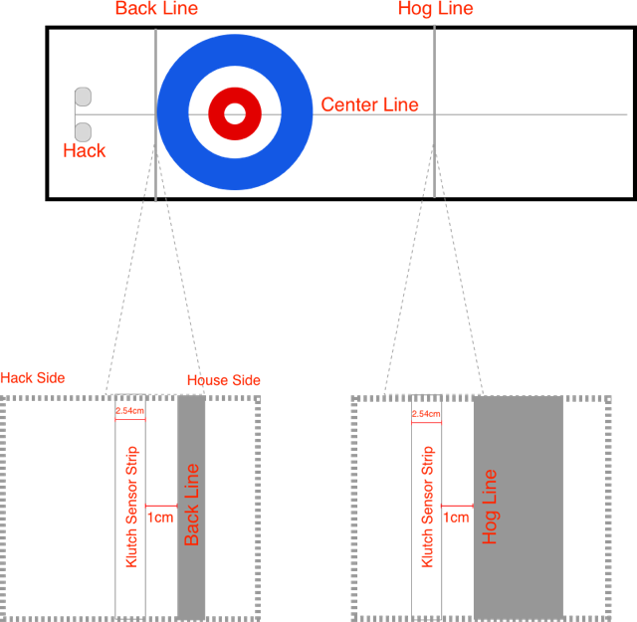

  - This side down. Please carefully note the sticker on the bottom side of the sensor strip. This side needs to be installed facing down. Upon inspection, you will note it’s the “groove side down”.

  - Sensor Strip length. Whether you are doing multiple sheets at one time or a single sheet, you can plan your installation to your preference.

      - In single sheet installations simply cut the 60 ft roll of sensor strip with scissors into 4 x 15ft lengths for each of the 4 lines.

      - In multiple sheet installations, you can either:
                - Install each sheet independently and cut the 60 ft roll of sensor strip into 4 x 15 lengths for each of the 4 lines; OR
                - Install all sheets together. You will receive a 60 ft roll of sensor strip for each sheet you are installing. That roll can be cut to whatever length you wish (15ft, 30ft, 45ft or leaving it at 60ft) so that you could install all hog or back lines simultaneously.

- Sensor Strip Placement in the ice. Once position has been determined, with a router carve a 1 ¼“ channel / groove in the ice, ½” deep (or deeper if desired), for the length of the sensor strip chosen. Insert sensor strip in the channel (please pay attention to installing the right side down). Spray the strip with water and allow to freeze in place.

- Sensor Strip Placement on the ice. After strips have been placed, spray the magnet with water and allow it to freeze in place. After which you can continue with the remaining flooding and ice installation. If the ends of the magnet curl up, put something heavy on them to hold them down until it freezes.

- Klutch Curling in-Ice Logo; In order for your members to know which of your sheets are Klutch enabled, please install the in-ice banner included in the box.

METHOD 2: Installation in Finished Ice

While the installation process is relatively straight forward the accuracy of the Klutch Curling App relies on the critical placement of the Magnetic Sensor Strips. Failure to perform all the steps described could impact the overall performance of the products. Please pay careful attention to all the steps below and if you have any questions please consult our website for further details or contact us for support.

We have found that each ice technicians process and installation method is unique and dependent on both the club and environment. To support that we have tried to be as flexible as possible in our approach to installation. Listed below are a number of key considerations

- Sensor Strip Depth. While the sensor strips can be installed at any depth in the ice, we recommend that they are installed after the initial painting of the hog and back lines to ensure the most accurate placement of the strips. Ideally, the magnet strips should have a minimum or ¼” or (6mm) of finished ice over the strip when complete.

- What colour do you want the Sensor Strip to be. Depending on where you install the sensor strips and the look and feel of your ice, you can choose to either install them in black (which many clubs have pushed so that people see the cool new technology) or if you wish them to be white, they can be ordered in either colour you prefer.

- Sensor Strip Length. For clubs that have already fully installed their ice we recommend that you install a single sheet at a time.

- Recommended: Simply cut the 60 ft roll of sensor strip with scissors into 4 x 15ft lengths for each of the 4 lines.
- Minimum: If you do not wish to install the full 15 ft for each line the min. required is 4ft for the back lines and 15 ft for the hog lines. You can cut the lengths required from the 60 ft roll of sensor strips.
- Sensor Strip Position. There are 4 sensor strips to be installed per sheet of ice; parallel along the back line and hog line for both ends of the ice.

- For each of the Hog lines, the sensor strip must be placed on the House side of the line, parallel and as close as possible to hog line but no more than 1 cm way.
- For each of the back lines, the sensor strip must be placed on the Hack side of the line, parallel and as close as possible to back line but no more than 1 cm way.

- Sensor Strip Placement in the ice. Scrap the ice first for best results. Once position has been determined, with a router carve a 1 1/8” channel / groove in the ice, ½” deep (or deeper if desired), for the length of the sensor strip chosen. Insert sensor strip in the channel (please pay attention to installing the right side down). Hint: Take the chips of ice that the router created and place these chips of ice on top of the ends of the magnet. Pack the chips down on the magnet which will hold the ends of the magnet in place. Spray the strip with water and allow to freeze in place. If the ends of the magnet curl up, put something heavy on them to hold them down until it freezes.

- This side down. Please carefully note the sticker on the bottom side of the sensor strip. This side needs to be installed facing down. Upon inspection, you will note it’s the “groove side down”.

- Klutch Curling In Ice Logo. In order for your members to know which of your sheets are Klutch enabled, please install the in-ice banner included in the box.

