SENSOR MODULE INSTALLATION GUIDE
Welcome to Klutch Curling!
This guide has been designed to help your ice technician(s) correctly install the equipment required to enable and use your Klutch Curling Sensor Modules with the Klutch Curling App.
We understand and appreciate the knowledge and experience that is essential for all professional ice technicians operating within their roles and responsibilities. Please use caution while ensuring that industry accepted methods and techniques are utilized during the installation process, as well as ensuring that installing Klutch technology does not interfere with your rock maintenance program. i.e. Periodic Handle Rotation.
Should you need assistance with changing batteries or installing the magnetic sensor strips, please see the other guides at www.klutchcurling.ca

Materials Included:
- Sensor Module in gasket
- 4.5 inch Bolts
- Allen Key for bolts (when bolts are 7/32”)
- Klutch Curling Rock Stickers
Equipment Needed
- Allen Key (typically 5/16” or 7/32”)
- An Android phone or iPhone with the Ice Technician App and the Klutch Curling App downloaded and installed from either the App Store or Google Play.
Key steps in the Installation Process
- Place the module under the handle and re attach the handle to the stone
- Using the Klutch Ice Technician App. to program the rocks to match your sheet and color
- Place Klutch Curling stickers on rocks

Part 1: Installing the Modules in the Rocks
Below is our simple 4 step process to install the Sensor Modules in their corresponding rocks. Installing each Sensor Module correctly is essential to the Klutch Curling app working properly for your members.
We recommend that you install and program 1 sheet at a time to minimize complexity.

Step 1: Removing the handle
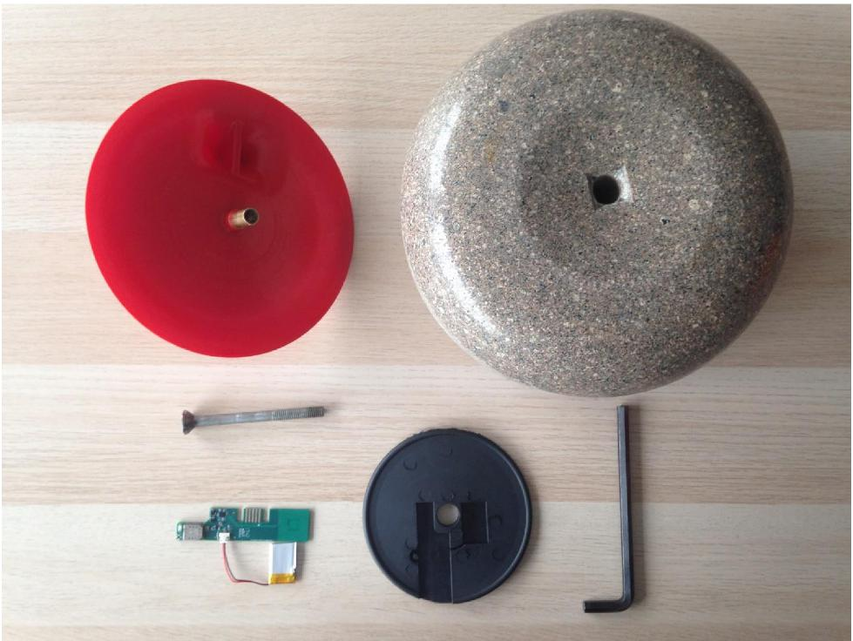
Remove the handle from the rock.
Remove the existing friction disk (if equipped) from under the handle.
Put it aside, we will be replacing it with the Gasket

Step 2: Removing the Battery Tabs
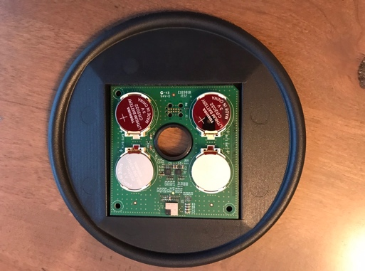
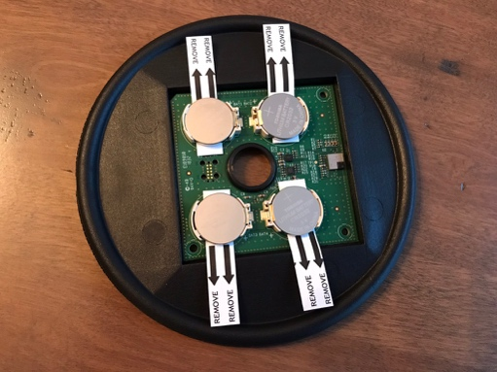

Remove the gasket and module from the anti-static bag.
You will find 4 white tabs situated between the battery and the circuit board
Remove each tab by pulling gently.

Step 3: Placing the Module
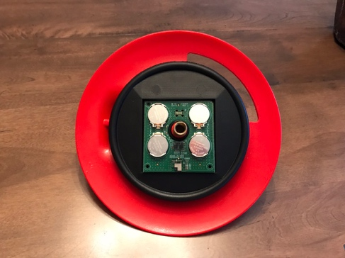
Take the module and place over the pin shaft of the handle.
The electronics should face “down” or towards the rock.

Step 4: Reconnect the rock handle.

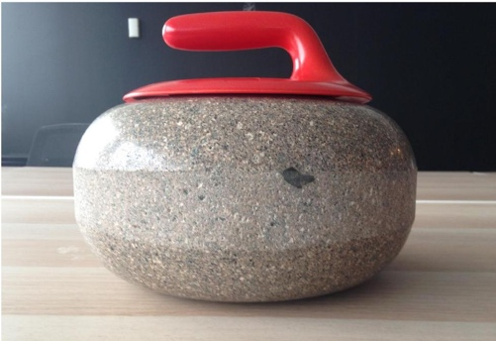
Place handle back on the top of the rock.

Hold the handle in place while tilting the rock so that you can screw the 4.5” bolt (not a 4.25” bolt) back in from underneath.
IMPORTANT: The bolts must be 4.5” long (the length of the ones we included). Some clubs already have this length bolt and/or some of the stones may have these bolts but it is very important to only use 4.5” bolts. The 4.25” bolts will damage the boards because they are too short.

PRO TIP: Tighten the bolt from below the rock. Never tighten it by spinning the
handle or it can cause damage to the sensor. Do not over tighten the handle. While tightening the rock, use the ice tech app with the phone next to the rock. Place the rock on its side and tighten the bolt. The number should fluctuate as you tighten. Stop tightening when the rock is relatively tight and it is around the 80’s when the phone is close to the rock. You should be measuring the rock with the phone as close as possible to the rock - ideally 2ft or less.
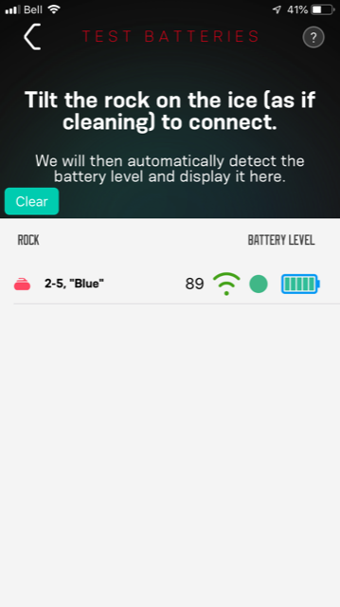

Repeat these steps for each of your curling rocks.

Part 2: Programming the Rocks
Below is our simple 5 step process to connect to each module using the Klutch Ice Technician app and program the module to the corresponding stone and sheet.
This process is essential to your club’s Sensor Modules being operational for Klutch Curling app use.

Step 1: Download the App

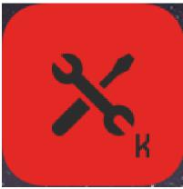
To program and set up the rocks you will need to download the “Ice Technician – Klutch” App.

You will find the app available on both the App Store and Google Play Store depending on your phone type and OS.

Step 2: Confirm no rocks are in “awake” mode
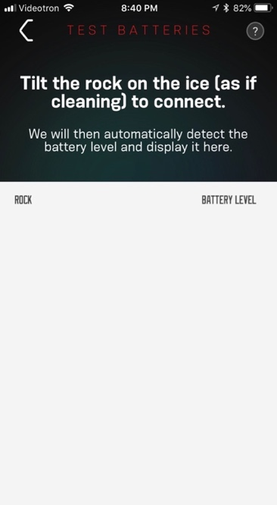
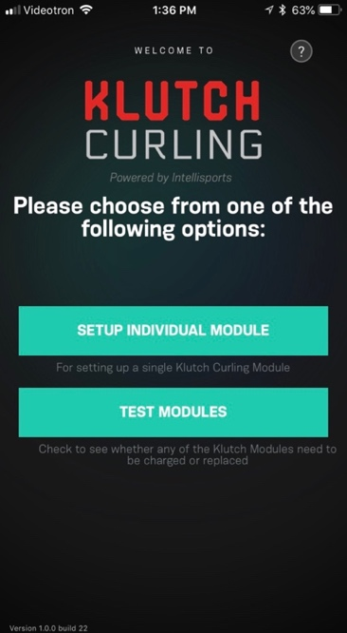
Before starting to program the rocks, please ensure that none of the rocks are in “awake” mode.
- Open the Ice Tech App and choose test modules.
- You should see a blank screen. If you see any rocks on the screen you will need to determine which are awake. Please confirm all rocks are flat on the ice. If still showing rocks awake please contact support at www.klutchcurling.ca and we’ll help you troubleshoot.

Step 3: Programming the modules / rocks
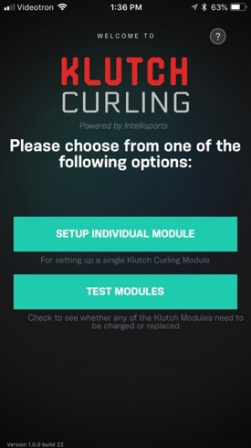
1. Open the Ice Technician App

2. At the welcome screen choose “SETUP INDIVIDUAL MODULE”

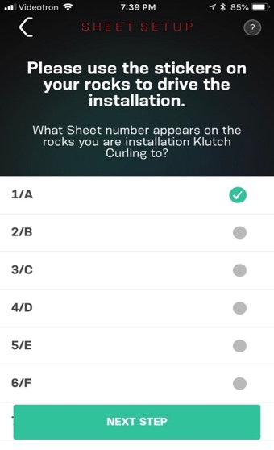
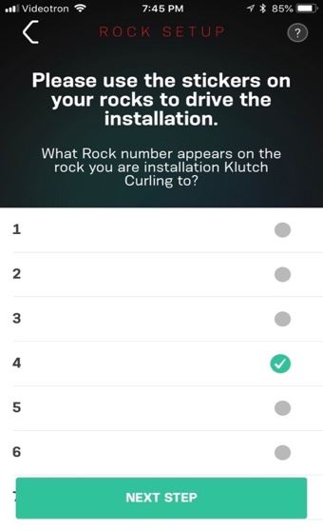
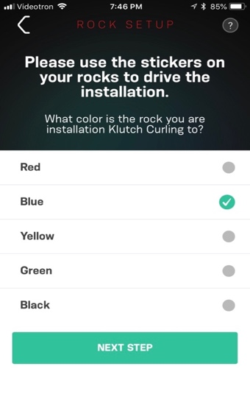

- Follow the instructions on the screen and choose the Sheet, the rock number and the colour you want to program.

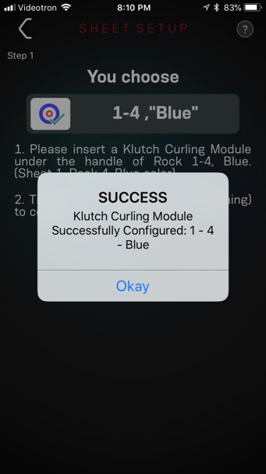
- Now tilt the rock perpendicular to the ice (similar to the motion you use to clean the bottom of the rock before a shot). This will “wake up” the rock. Once the rock wakes up it will automatically pair with the Ice Tech App and program the module the sheet, number and colour you set up.
NOTE: If you are re programming a rock that has been set up in the past, you will get a WARNING note advising that you are about to over write it.

- Go back to step 1 and repeat the steps for each rock you are setting up.
Step 4: Testing the modules
To verify your setup or check on the naming or status of a rock, the Ice Tech App comes with Testing function. To test the modules:
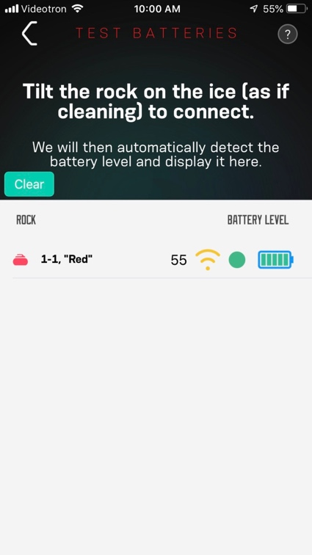
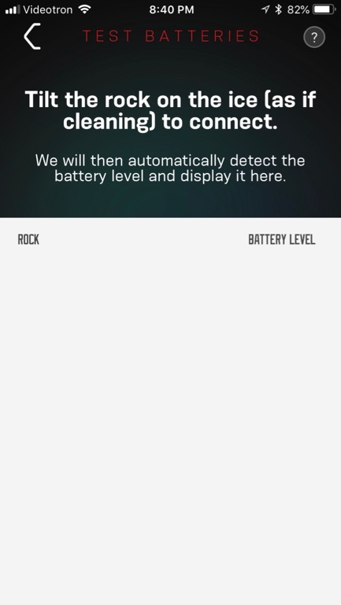
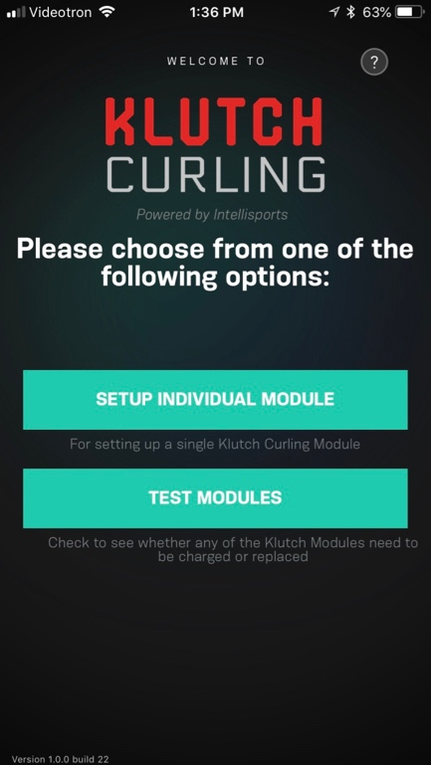

- Open the Ice Technician App and at the welcome screen choose “TEST MODULES”
  - You should be measuring the rock with the phone as close as possible to the rock - ideally 2ft or less.
- Tilt the rock on the ice (as if cleaning it) to “wake up” the rock and connect to it
- Once the connected, you will be able to see the following:
  - Label (sheet and stone number) of the rock / module
  - Signal Strength. You will see a number and a ''wifi'' symbol that will be either green for all good, yellow for medium (it will be hit and miss on hog to hog) and red for bad (will generate lots of missed shot recordings). For rocks that are not green, we suggest you release the tension on the bolt (use small increments - less than a quarter of a turn) and see how it impacts colour and number real time. Repeat this process until the wifi symbol reads “green” and the number beside the wifi symbol is as a large as possible.
- Rock Function indicator. The circle will be green if the module is performing properly and red if there’s an issue
- Battery indicator – shows the strength of the batteries in the module

Part 3: Installing the Klutch Curling stickers on the Rocks
To provide visibility to your members on which sheets and rocks are Klutch Curling enabled, we have included “rock stickers”. We recommend that he stickers be applied anywhere on the flat part on the rock handle, except the actual handle part where the curlers hand holds it.

Please note that the batteries drain if the rock/module is not flat like it is on the ice. So if you turn the rocks over for a period of time (eg. during the summer or flood), you should either keep the rocks flat or take out the modules and stack them flat. You can see if the modules are flat or not by using the ice tech app to see if they show up. If you don’t see any rocks, the modules are flat.

